May 6th, 2026
For: Troy Scevers
CST 351– DIGITAL SYSTEM DESIGN II
Midterm
Serial Logger
For: Troy Scevers
Table of Contents
Abstract 2
Introduction 3
Design 3
Physical hardware design 3
Synthesized hardware design 3
Design Structure 4
Modules 4
Simulation and Testing 5
Problems 5
Results and Conclusion 6
Appendix 7

Abstract

This midterm focused on creating a serial output logger in verilog. The output of the serial logger was based on the current state of a set of traffic lights, as well as the inputs given to the traffic lights. The traffic lights were to represent a highway intersection off of a small farm road, which would change only when a car was detected on the farm road, and was to maximize the amount of time that the highway lights would stay active. On a reset or car detected, the serial logger output a respective message about the input received. When a state change was detected, the outputs of the new state were transmitted. This design was made of a state machine that controlled the traffic light logic, a UART transmitter that ran at 9600 baud, a block of memory that held the information to transmit, and a memory controller.

Introduction

The goal of this lab was to design and implement a UART receiver that worked for a 9600 baud transmitter. This means that the receiver needed to oversample, and it ran at 16 times the speed of the transmitter. The modules used in part one were a clock divider, a UART receiver, and 2 seven segment display decoders (Figure 1). This part of the lab focused on receiving an input from a keyboard, and displaying the hex code on the integrated seven segment display LEDs of the DE1-SOC board that was used. The modules used in part two were a clock divider, a UART receiver, a lower-to-uppercase converter, and a UART transmitter (Figure 2). This part of the lab received a character input from a keyboard, and then checked if the input was uppercase or lowercase. Then, it would transmit the uppercase version of that character, regardless of the casing it was sent in.
The goal of this midterm was to design and implement a serial logger in verilog.

Design

Physical hardware design
The chip used was the DE10-SOC board. This board was provided to use for this assignment, and thus it was used. Two common anode RGB LED lights were also used as a way to represent the current color of the traffic lights, as well as a USB to UART, which allowed the serial logger to output to a computer for output verification.
The DE10 board has several IO components which were utilized during the implementation of this assignment. The common reset was wired to switch 0, and the input to the state machine was wired to key 0. The VCCand ground pins of the USB to UART were wired to pins 29 and 30 respectively, as these pins are always at 3.3V and ground. The UART transmitter module was wired to output to GPIO 0, which connected to the receiver pin on the external UART to USB module. The RGB LED representing the farm lights was connected to GPIO pins 1, 3, and 5, while the RGB LED representing the highway lights was connected to GPIO pins 31, 33, and 35.

Synthesized hardware design
The modules designed in verilog for this assignment consisted of a UART transmitter, a clock divider, a traffic state controller, a block of read-only memory, and a memory controller (Figure 1). The UART transmitter ran at a baud rate of 9600, had a single stop and start bit, and had a single bit of parity. The clock divider was designed to be parameterized, and defaulted to a 1Hz clock. The traffic state controller consisted of 4 states and 4 respective outputs. The memory was a byte-addressable block that output the character at the input address. The memory controller was a state machine that grabbed the required characters from the memory to output to the UART transmitter.

Design Structure
The flow of data in this design starts at the clock dividers. The 1Hz clock divider connects to the traffic light state machine, which then connects to the GPIO output. The traffic light state machine is also connected to the input of the memory controller, which is driven by a 9600Hz clock divider. The memory controller is connected to the memory block, which is in turn connected to the UART transmitter module, which is connected back to the GPIO output.

Modules

Clock Divider
The inputs of the clock divider consist of the system clock, a reset bit, and an enable bit. The output is a single bit that acts as a slower clock than the system clock.

UART Transmitter
The UART transmitter has 4 inputs, consisting of a clock signal, a reset bit, a start signal , and an 8-bit character-in. The UART transmitter has 2 outputs, a single transmit bit and a busy signal. The start signal is used to activate the UART transmitter, while the 8 bits of data-in represent the ascii code of any character. The reset terminates any in-progress transmission. The transmit bit output is used to indicate to a connected receiver when the transmitter has a character ready to send, and goes bit-by-bit through the character from LSB to MSB. The busy signal indicates that the UART transmitter is not currently able to accept new data.

Traffic Controller
The traffic controller has 3 inputs, consisting of a clock signal, a reset bit, and a sensor bit. The traffic controller has 2 outputs, both being 3 bits wide, a highway light output and a farm light output. The outputs are updated based on the sensor input, cycling between a 4 second state where the highway light is yellow and the farm light is red, a 6 second state where the farm light is green and the highway light is red, a 4 second state where the farm light is yellow and the highway light is red, and an idle state where the highway light is green and the farm light is yellow.

ROM
The read-only memory has 2 inputs, which are a clock signal and an address. The memory has a single output, which is an 8-bit character. On the positive clock edge, the address input is read, and the byte at that address is sent to the output.

ROM Controller
The memory controller has 4 inputs, consisting of a clock signal, a reset bit, and the sensor bit concatenated with the 6 bits from the traffic controller. The memory controller has 2 outputs, one being a control signal for the UART transmitter, and the other being a 5 bit address to send to the ROM. The output is the address of each character to send in a message as a log based on the input.

Simulation and Testing

The testing of the UART module (Figure 6) was a simple script verifying that all of the bits were output for the appropriate amount of time relative to the input clock signal. The test verified that neither changing the input character nor turning off the enable signal during transmission would affect the resulting output.
The testing of the ROM (Figure 4) was simple. The script ran through all of the possible inputs and verified that the output matched what was loaded into the ROM module.
The ROM controller test (Figure 5) was much more complex. The first verification was that the state would not change unexpectedly while sending a message. The next verification was that any given message would not unnecessarily repeat itself- a single press of the button should only log a single instance of a car being detected, a single flip of the reset switch should only result in a single reset message being sent, etc. The outputs were also required to match what each message should be, as well as the length of the message. If the input changed (a reset was hit in the middle of the state change), an internal flag was to be raised and cleared only when the message was sent. This testing script was incredibly helpful for debugging some of the issues encountered during implementation.
The traffic light controller test (Figure 3) verified that when a car was detected, the states would be cycled through in the appropriate amount of time.

Problems

The biggest issue encountered was the fault in the initial design. A module was missing, resulting in an implementation which rendered the ROM a redundant part of the design. This caused the design of the ROM controller to be incredibly complex, which made debugging issues a pain.
Some of the issues encountered as a result of the complex ROM controller design included duplicated messages, invalid formatting of the messages, and characters being skipped during transmission. To fix duplicated messages, internal registers were added to act as flags, and prevent messages from being sent more often than was necessary. To fix the invalid formatting of the messages, the output addresses of each character had to be readjusted, and extra characters had to be added. While the minimal size of the ROM itself made these adjustments easy, grabbing the correct character was still difficult. To fix characters being skipped during transmission, the clock speed of the ROM controller was adjusted to be the same as the UART transmitter. However, another solution would have been to read the busy signal from the UART transmitter, and only increment to the next character when the busy signal went low. The current design does not verify that the UART transmitter is not busy, which means that it is possible to have errors in the UART transmission.
Another issue was that the ROM only had one instance of each unique character in the message instantiated within itself, which made the ROM implementation simple, but also completely redundant. The better decision would have been to have each message encoded entirely within the ROM, and have a counter that incremented through the ROM from some starting address through to the length of any given message. This would have resulted in a much simpler design and implementation for the ROM controller, and would have made debugging much simpler. The reason that this implementation was avoided was simply because encoding all of those characters seemed to be a lot of work- what the designer had not considered was that the current implementation not only required the same amount of work of encoding the characters, but required much more work to work around the poor design.

Results and Conclusion

This midterm was an exercise of design. Each of the modules was relatively simple, and being able to use previously existing IP from previous classes should have made implementation fast. However, poor planning resulted in the newly-created modules being overly complex and redundant. Had more time been spent considering which implementation to take, a lot of time could have been saved, and a much cleaner design could have been achieved.
However, despite the design being a lot more clumsy than it should have been, it still produced the proper results. When the states change, or when any inputs are detected, the logger is able to catch and output a human-readable message, and transmit it via UART.

Appendix
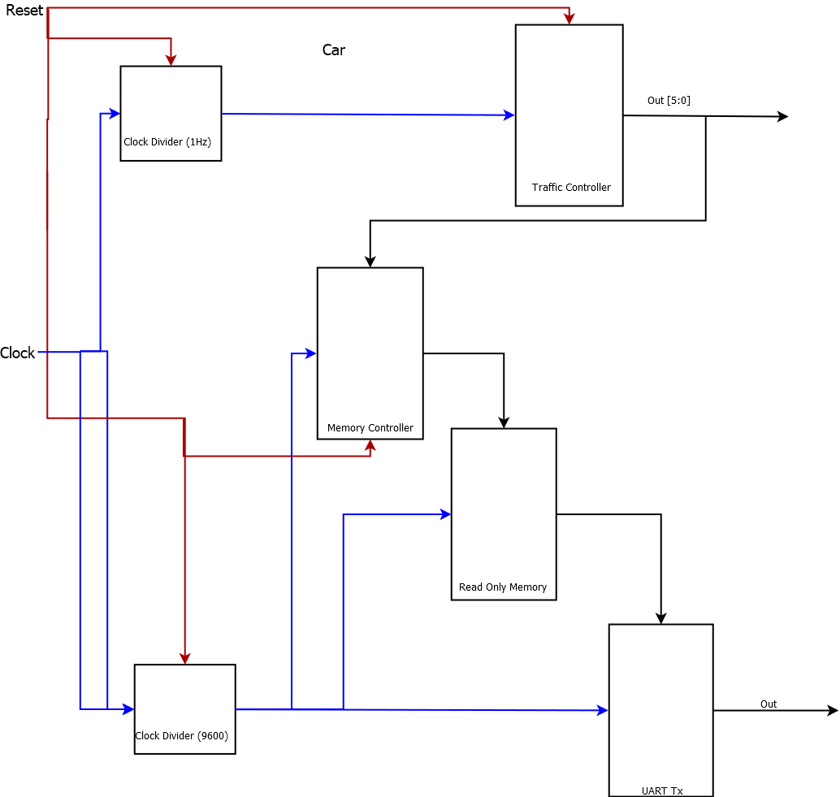Figure 1, Midterm Top Level Schematic

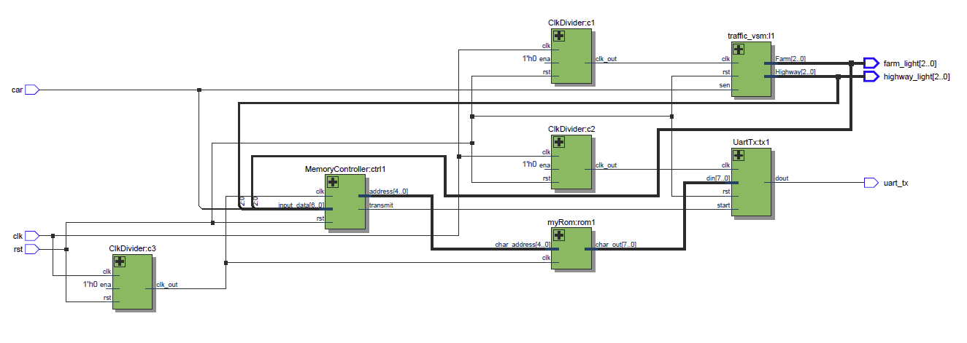Figure 2, Midterm Top Level RTL

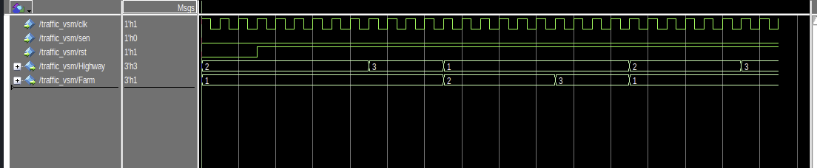Figure 3, Traffic SM Waveform

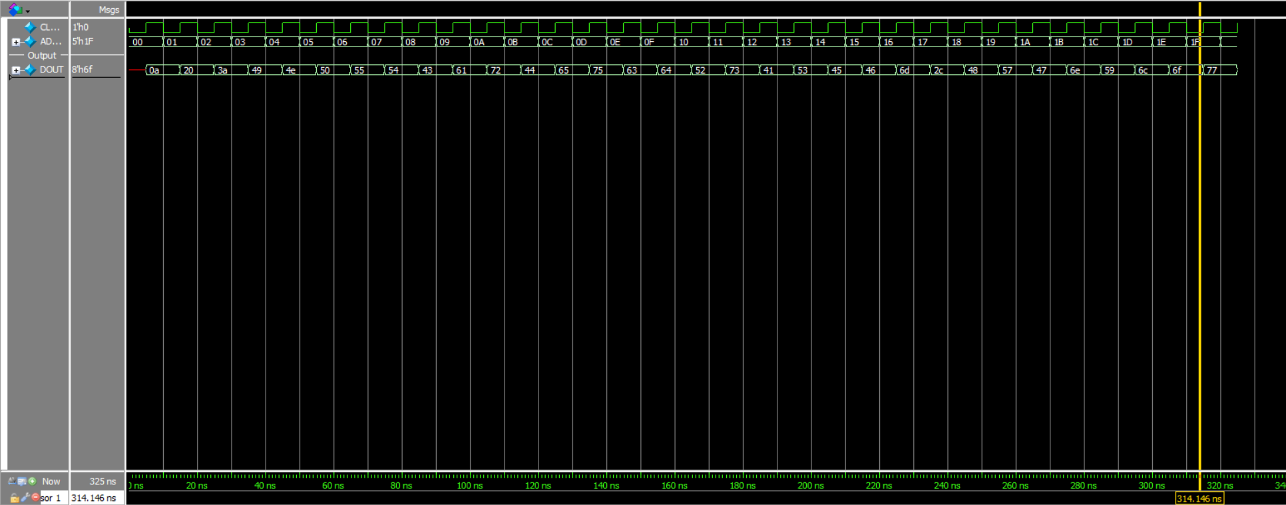Figure 4, ROM Waveform
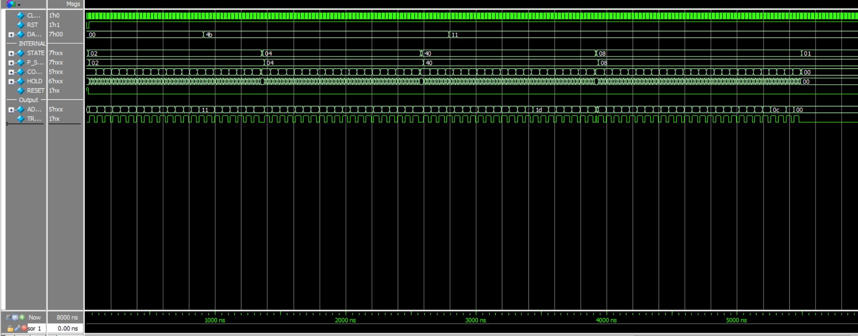Figure 5, ROM Controller Waveform

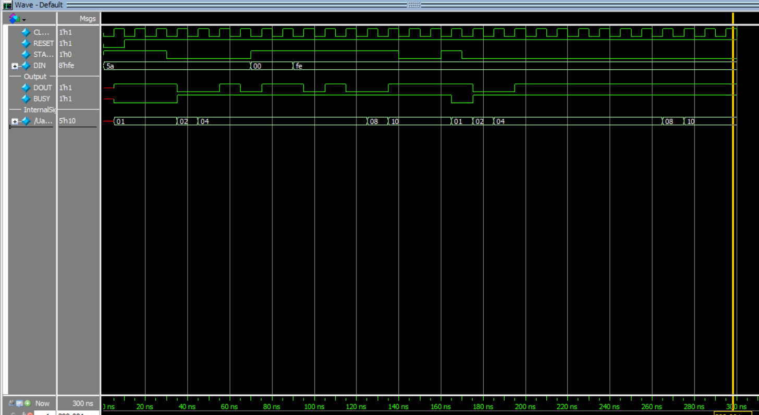Figure 6, UART TX waveform

